

BIT4138 ADVANCED CRYPTOGRAPHY

RYAN NDERITU BSCCS/2024/42638

GitHub Repository: https://github.com/ryan30-tech/advanced-cryptography

MAY 2026

Contents
PRACTICALS 3
WEEK 1 TASKS: Cryptography Environment Setup 3
Installation and Configuration of Cryptography Development Environment 3
Fig 1: Installation of Python 3
Fig 2: Installation of VS Code 3
Fig 3: Installation of Cryptography Libraries 4
Fig 4: Local Encryption Script Execution 4
Fig 5: GitHub Repository Initialization 5
Student Reflection 5
WEEK 2 TASKS: Classical Cryptography and Cipher Design 6
Implementation of Classical Encryption Algorithms 6
Fig 1: Caesar Cipher Implementation 6
Fig 2: Vigenère Cipher Encryption Process 6
Fig 3: Encryption and Decryption Output 7
Fig 4: User Input Validation Interface 7
Fig 5: Cipher Testing Results 8
Student Reflection 9
WEEK 3 TASKS: Stream Ciphers and Randomness Testing 9
Implementation of Stream Cipher Systems and Random Sequence Analysis 9
Fig 1: LFSR Generator Implementation 9
Fig 2: Pseudorandom Sequence Output/ Statistical Randomness Testing 10
Fig 3: RC4 Stream Cipher Simulation 10
Fig 4: Encryption Performance Results 11
Student Reflection 11
WEEK 4 TASK: Block Cipher Design and AES 12
Advanced Encryption Standard (AES) and Block Cipher Operations 12
Fig 1: AES Encryption Script 12
Fig 2: Key Generation Process 12
Fig 3: File Encryption Demonstration 13
Fig 4: Decryption Results 13
Fig 5: AES Performance Testing 14
Student Reflection 14
WEEK 5 TASK: Public Key Cryptography (RSA) 14
Implementation of RSA Encryption and Key Management 14
Fig 1: RSA Key Pair Generation 15
Fig 2: Public Key Encryption Process 15
Fig 3: Private Key Decryption Results 16
Fig 4: Secure Message Transmission 16
Fig 5: RSA Testing and Validation 17
Student Reflection 17

PRACTICALS

WEEK 1 TASKS: Cryptography Environment Setup

Installation and Configuration of Cryptography Development Environment

Fig 1: Installation of Python
version installed and confirmed is python 3.11.9

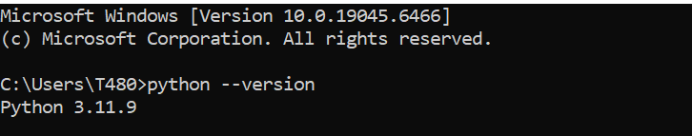

Fig 2: Installation of VS Code
VS Code configured successfully for Python development.

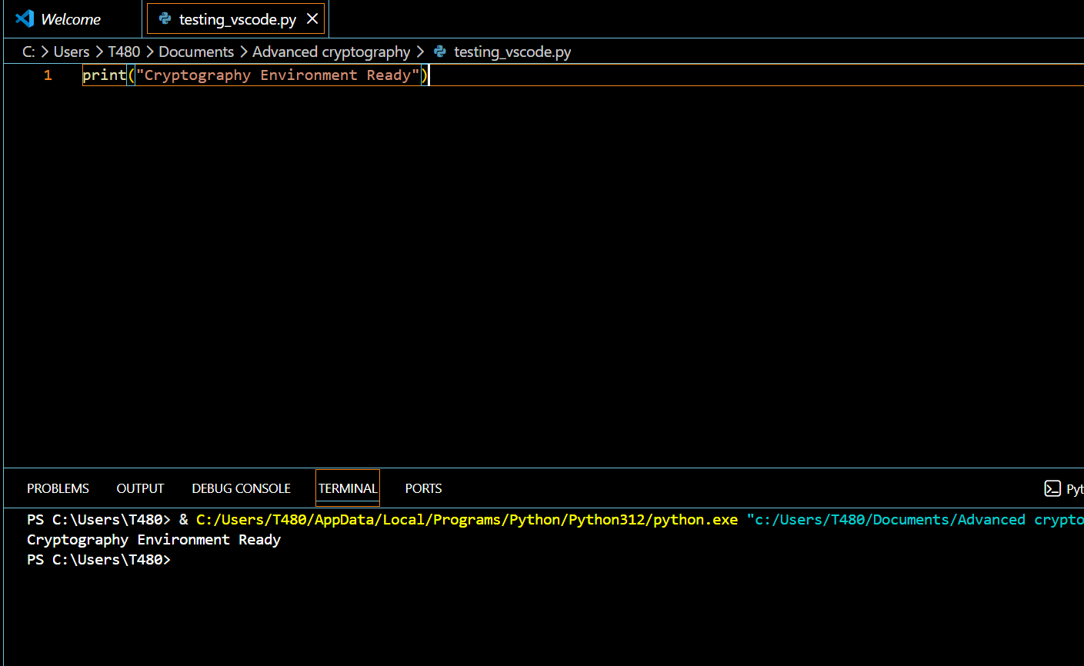

Fig 3: Installation of Cryptography Libraries
This figure shows cryptography library installed successfully using pip.
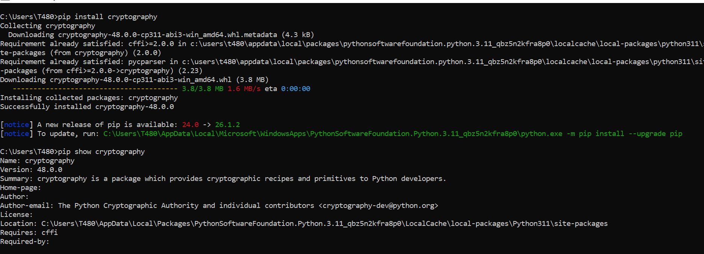

Fig 4: Local Encryption Script Execution
The word ‘hello hunter’ is encrypted to ‘Khoor#Kxqwhu’

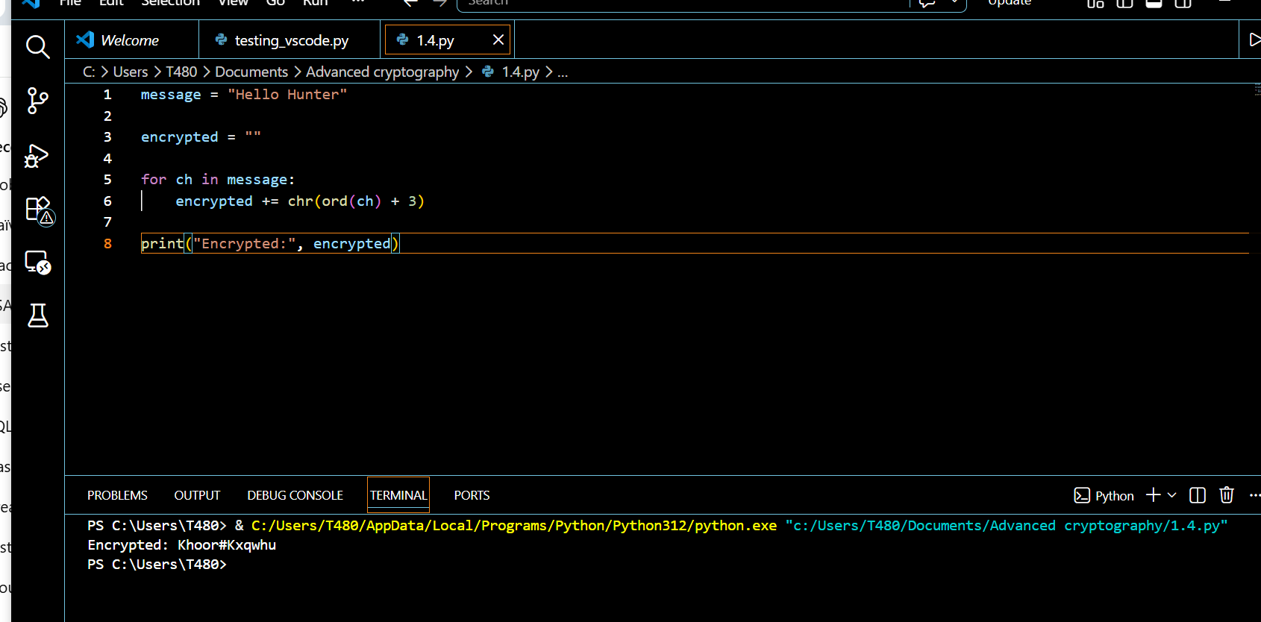

Fig 5: GitHub Repository Initialization

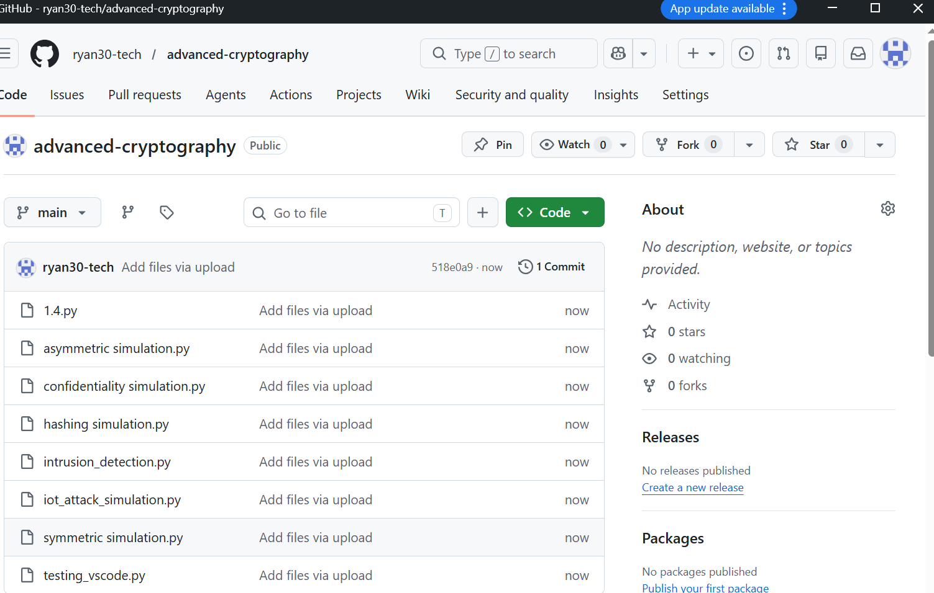

Student Reflection
I have successfully configured Python, VS Code, Cryptography library, and GitHub environment. For OpenSSL it wasn’t a free software. I have also tested a basic encryption script and verified all required security tools. The setup provides a foundation for implementing and testing cryptographic algorithms throughout the unit.

WEEK 2 TASKS: Classical Cryptography and Cipher Design

Implementation of Classical Encryption Algorithms

Fig 1: Caesar Cipher Implementation
This figure shows the successful implementation of Caesar cipher on user supplied plaintext.
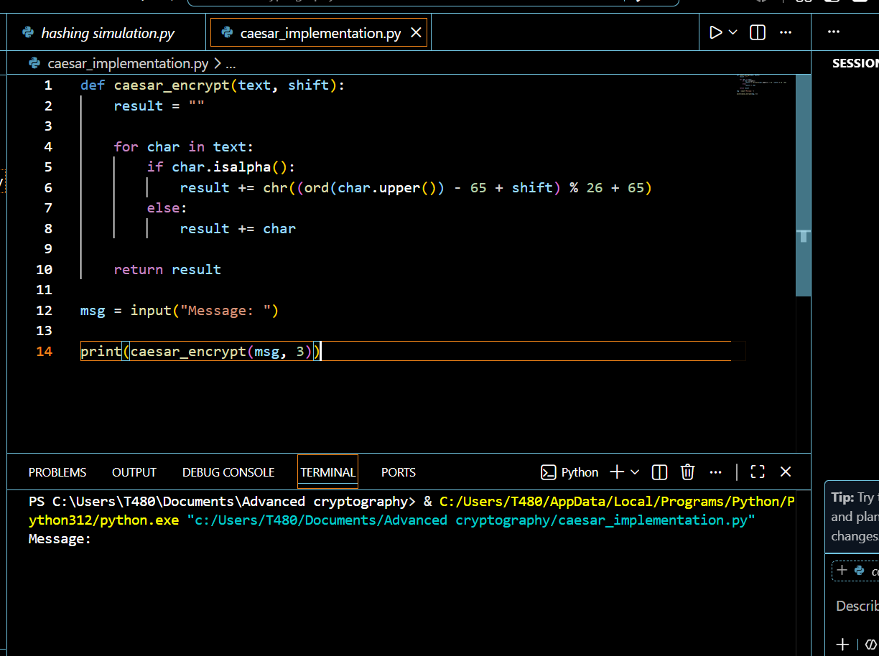

Fig 2: Vigenère Cipher Encryption Process
This cipher encrypted the word ‘hello” to ‘rijvs” using a key
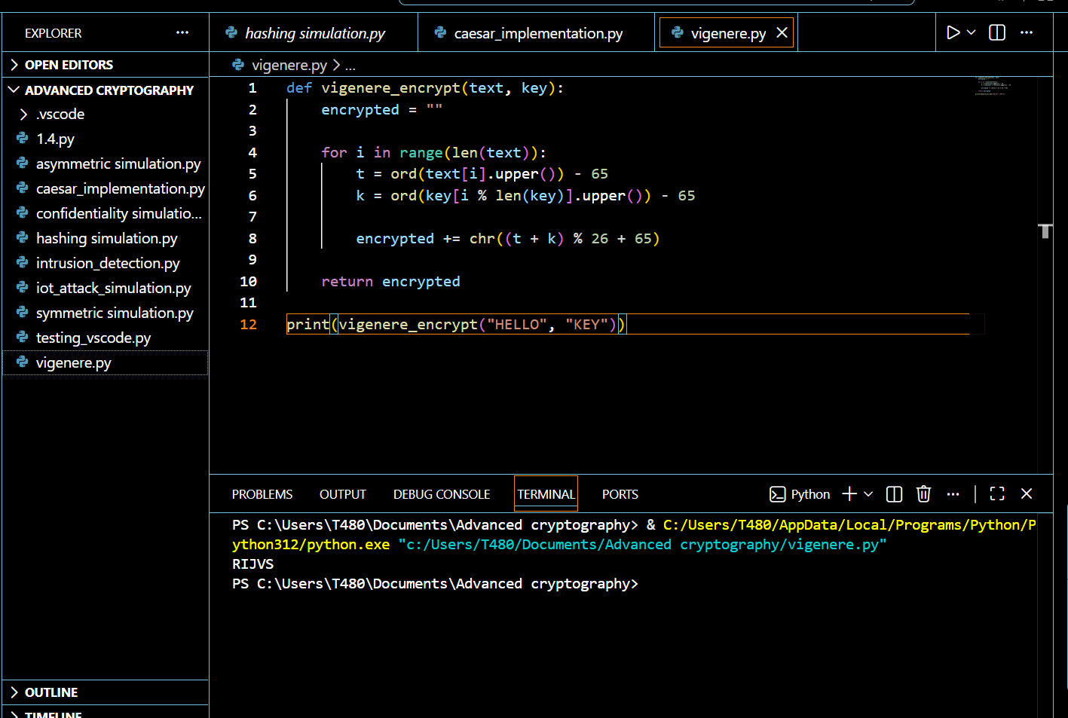

Fig 3: Encryption and Decryption Output
Here we encrypted the number ‘88’ to cipher text of ‘11’

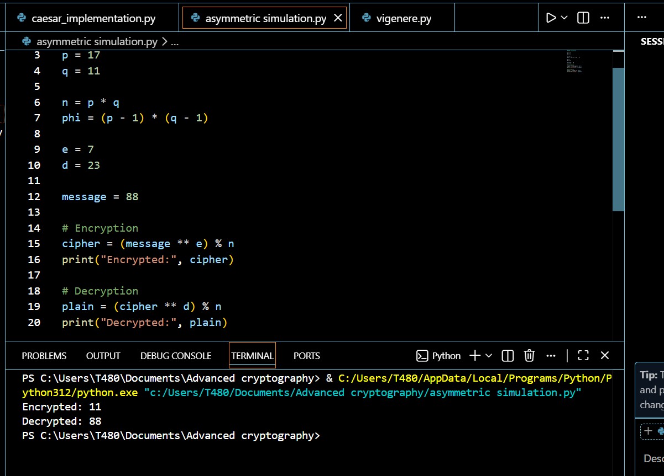

Fig 4: User Input Validation Interface
Using this validation interface we are able to maintain integrity, in place of a number a letter cannot be accepted and vice-versa

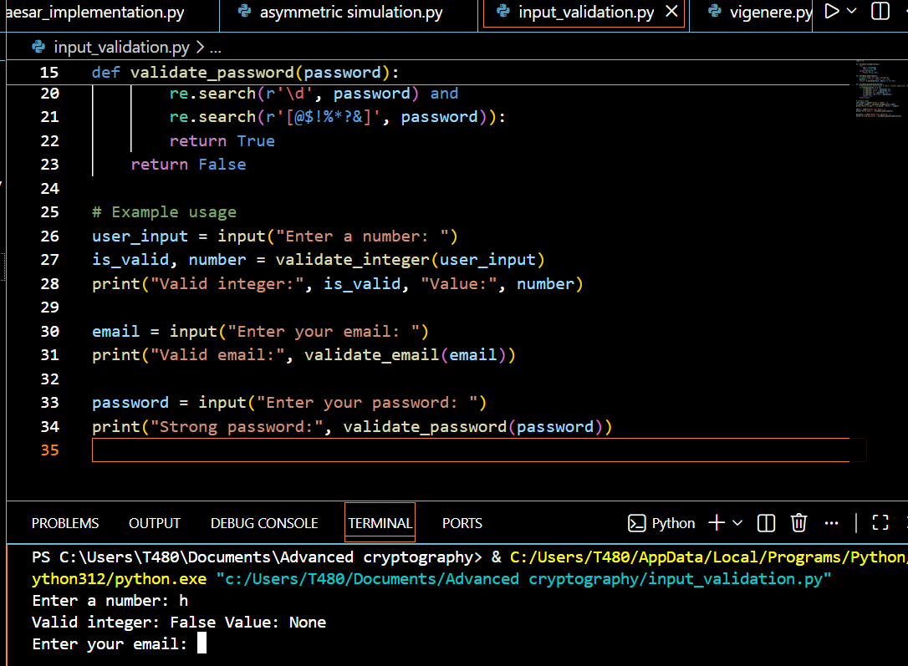

Fig 5: Cipher Testing Results

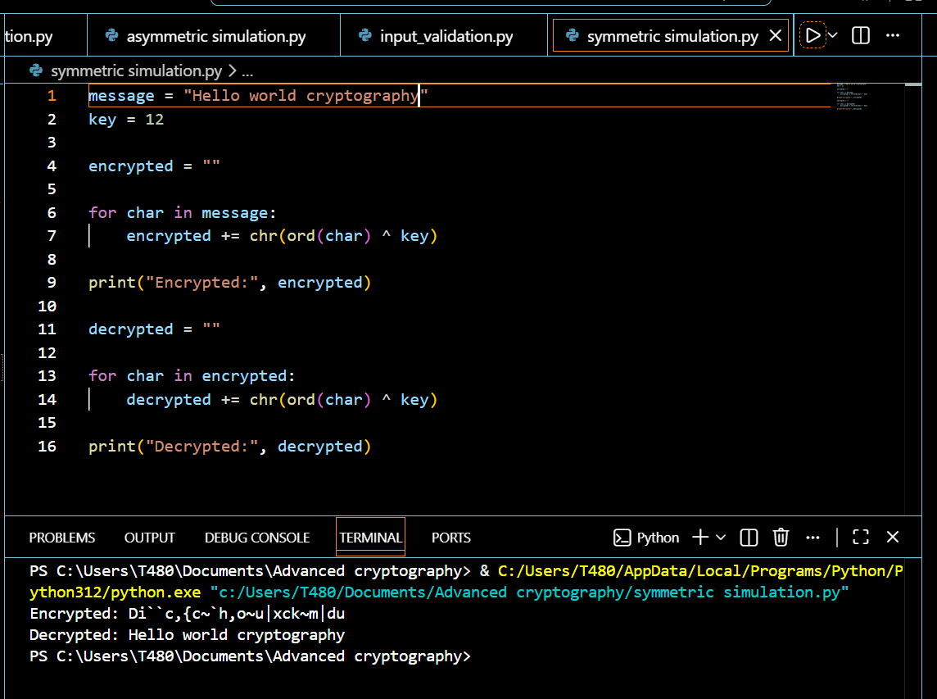

Student Reflection
I have implemented Caesar and Vigenère ciphers to understand classical encryption techniques. Tested encryption and decryption workflows, validated user inputs, and observed how encryption keys affect ciphertext security making the Vigenère more secure than Caesar.

WEEK 3 TASKS: Stream Ciphers and Randomness Testing

Implementation of Stream Cipher Systems and Random Sequence Analysis

Fig 1: LFSR Generator Implementation
This figure shows how a sequence of 20bits is generated from an initial seed.

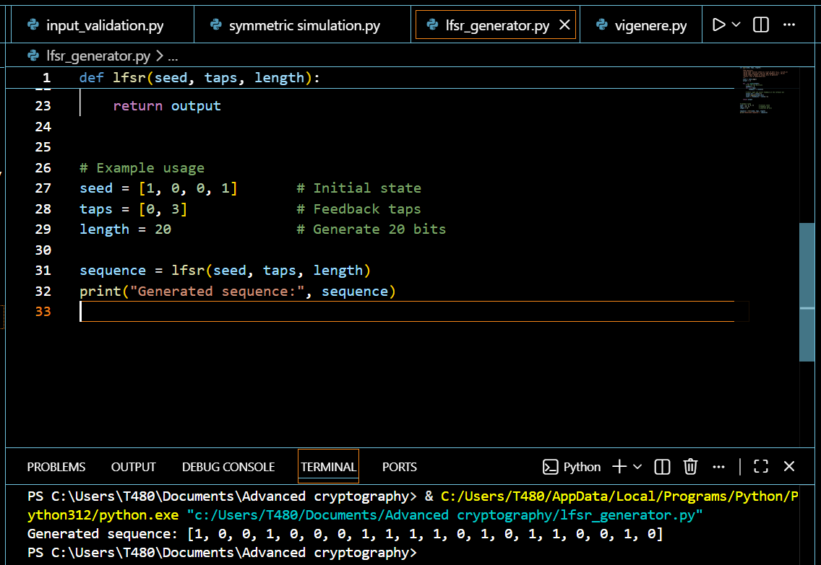

Fig 2: Pseudorandom Sequence Output/ Statistical Randomness Testing
This test checks whether it has equal number of 0 & 1 bits
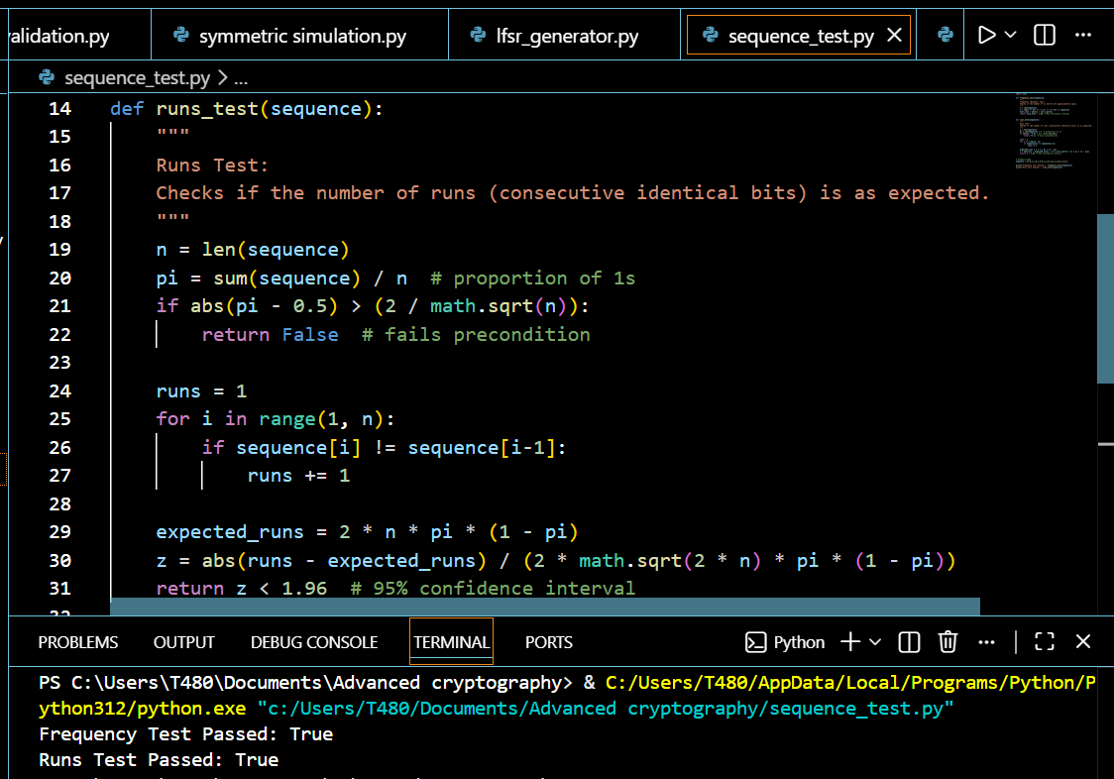

Fig 3: RC4 Stream Cipher Simulation
This figure shows the encryption of a word to cipher of numeric values that are generated using the LFSR.

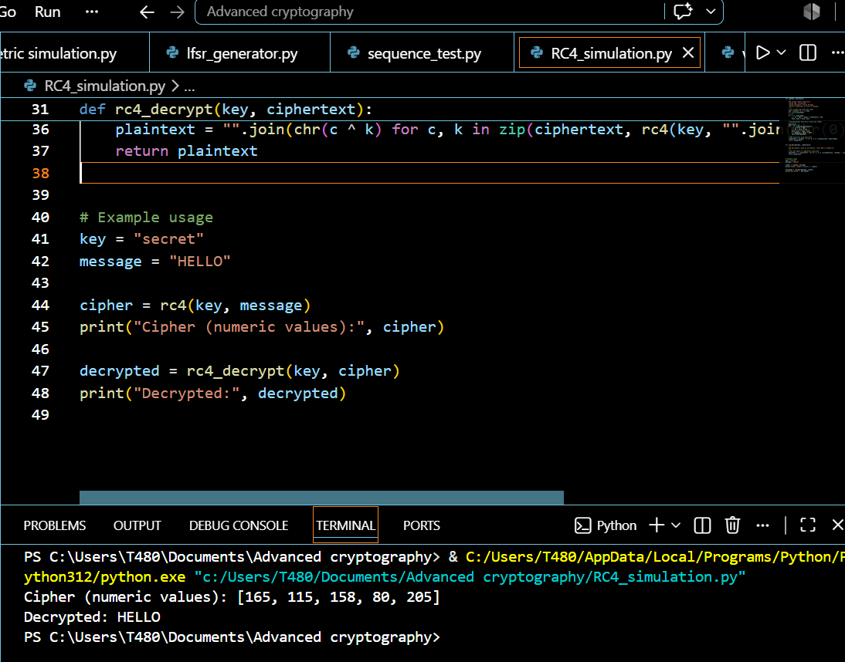

Fig 4: Encryption Performance Results
This figure shows the performance time of encryption using the XOR algorithm for 1000runs

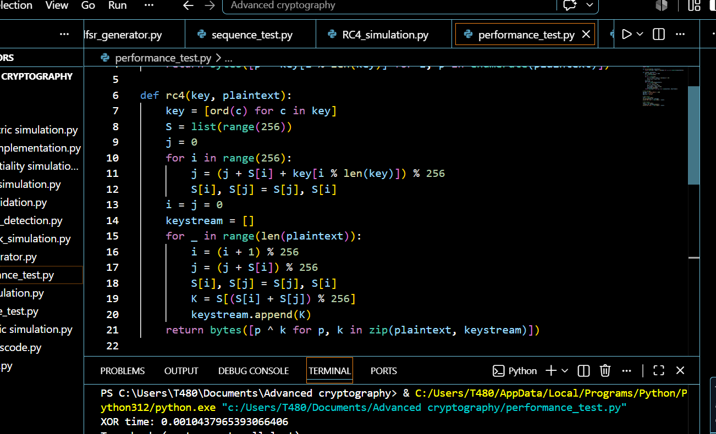

Student Reflection

I have implemented pseudorandom sequence generation and stream cipher concepts. Randomness testing demonstrated the importance of unpredictable key streams, while performance evaluation showed the efficiency of stream-based encryption methods.

WEEK 4 TASK: Block Cipher Design and AES

Advanced Encryption Standard (AES) and Block Cipher Operations

Fig 1: AES Encryption Script
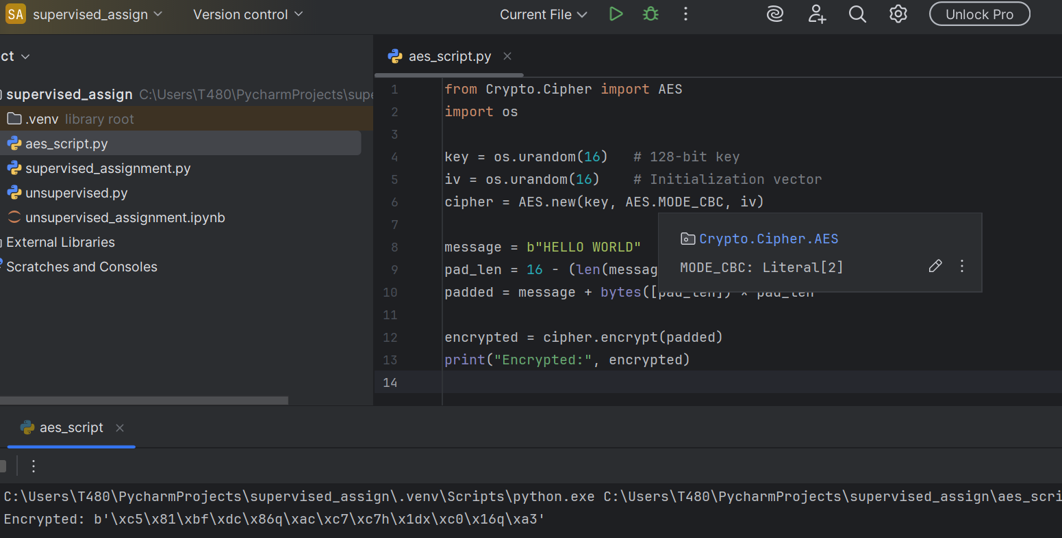

Fig 2: Key Generation Process
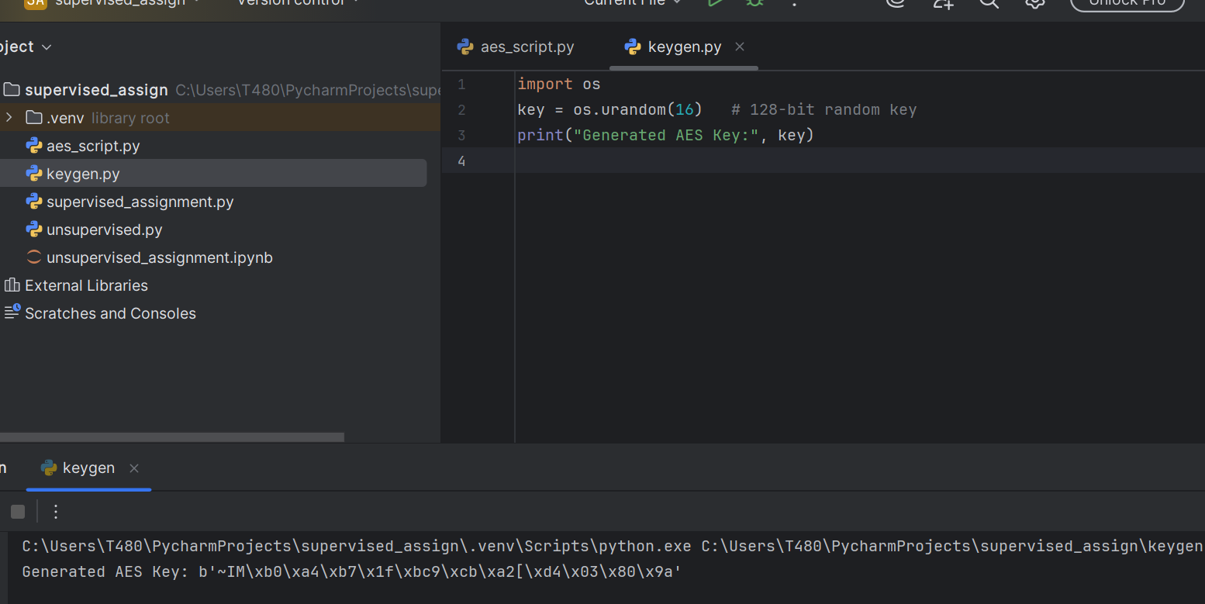

Fig 3: File Encryption Demonstration
A file is placed inside the same folder then it is encrypted
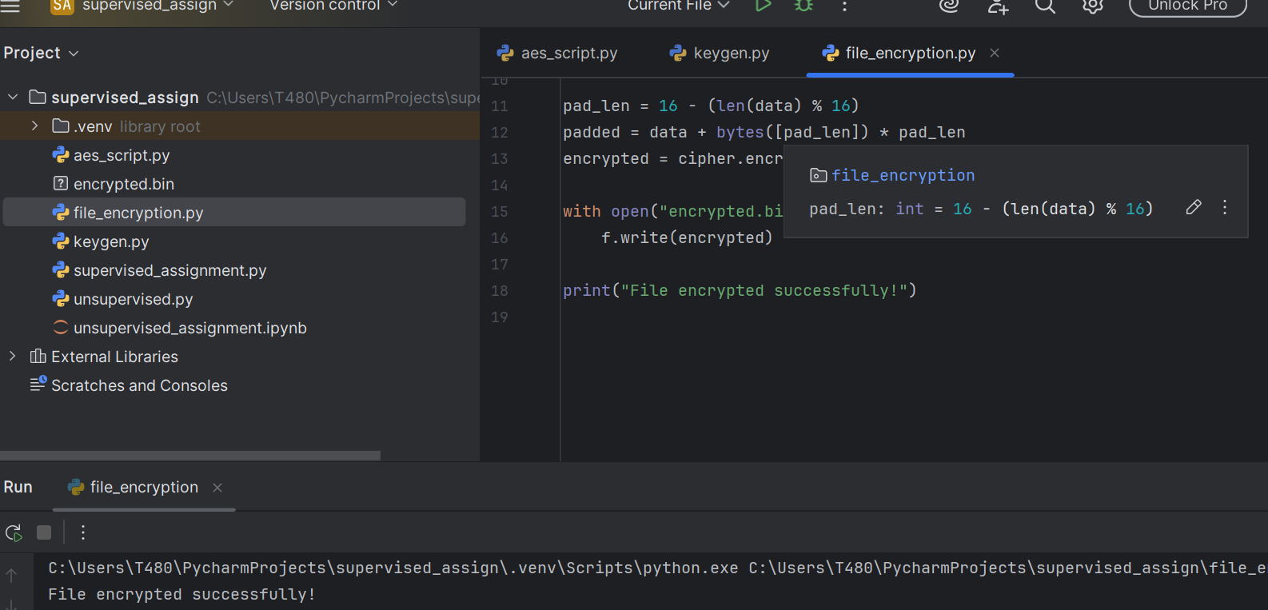

Fig 4: Decryption Results
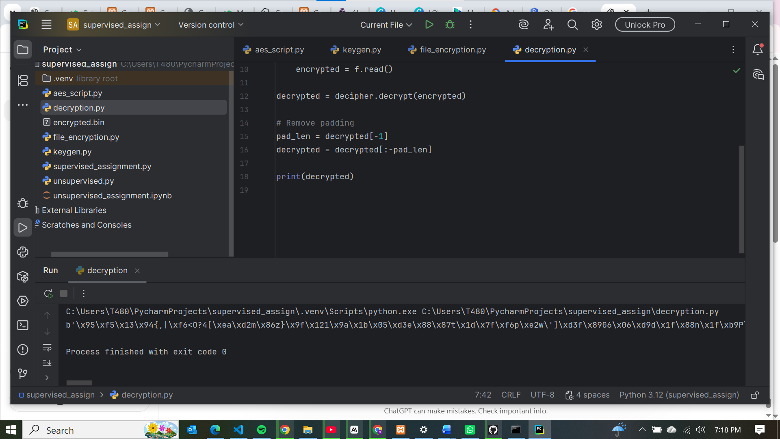

Fig 5: AES Performance Testing
Figure 5 shows the encryption time for AES in seconds in 1000 runs for the word ‘hello world’
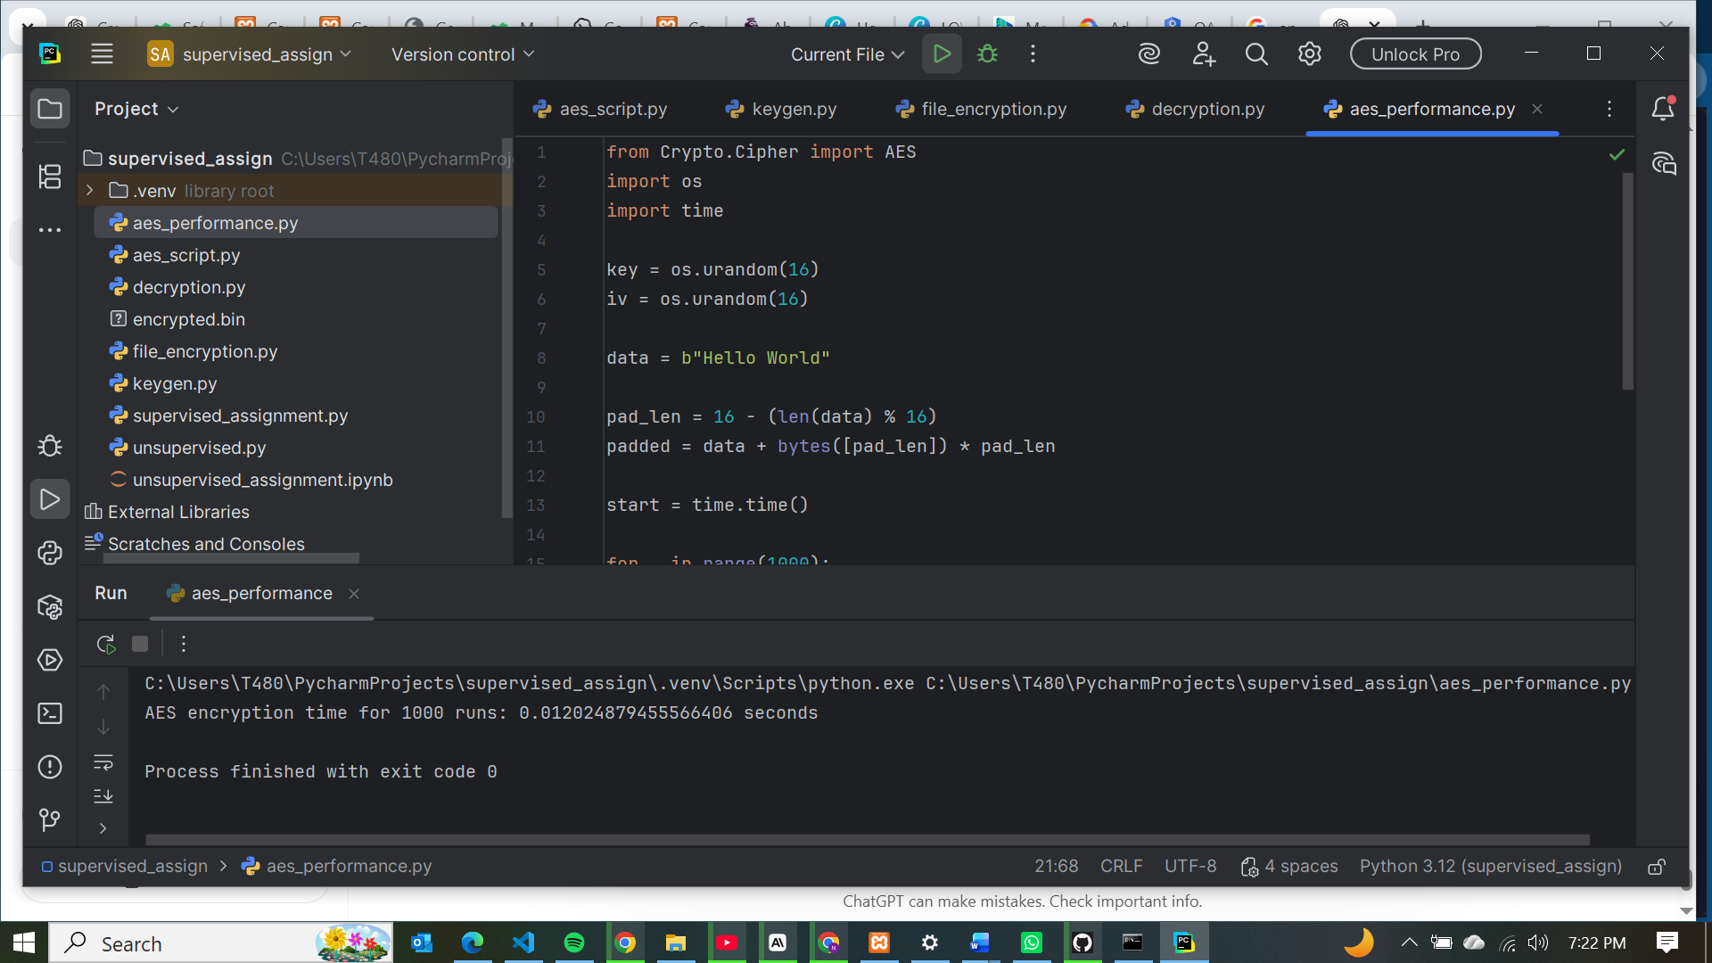

Student Reflection
The above screenshots show how I have implemented AES-based symmetric encryption using Python's cryptography library. Successfully generated keys, encrypted and decrypted messages, and protected files. Testing confirmed secure key handling and reliable encryption functionality. AES implementation presented challenges such as library installation, key and IV management, and decryption errors related to padding and encoding.

WEEK 5 TASK: Public Key Cryptography (RSA)

Implementation of RSA Encryption and Key Management

Fig 1: RSA Key Pair Generation
This figure shows the successful generation of public and private key.

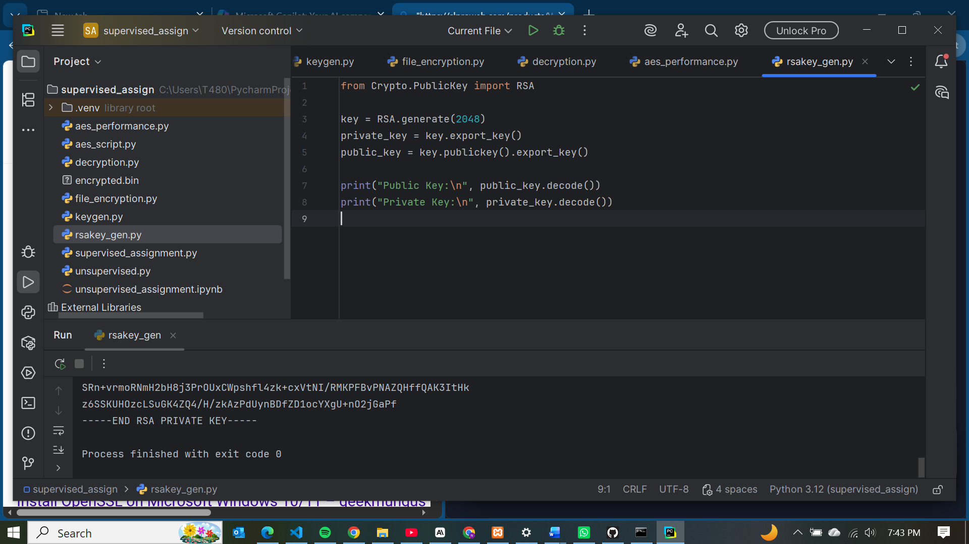

Fig 2: Public Key Encryption Process
This figure shows public key generation which is used to encrypt the message.
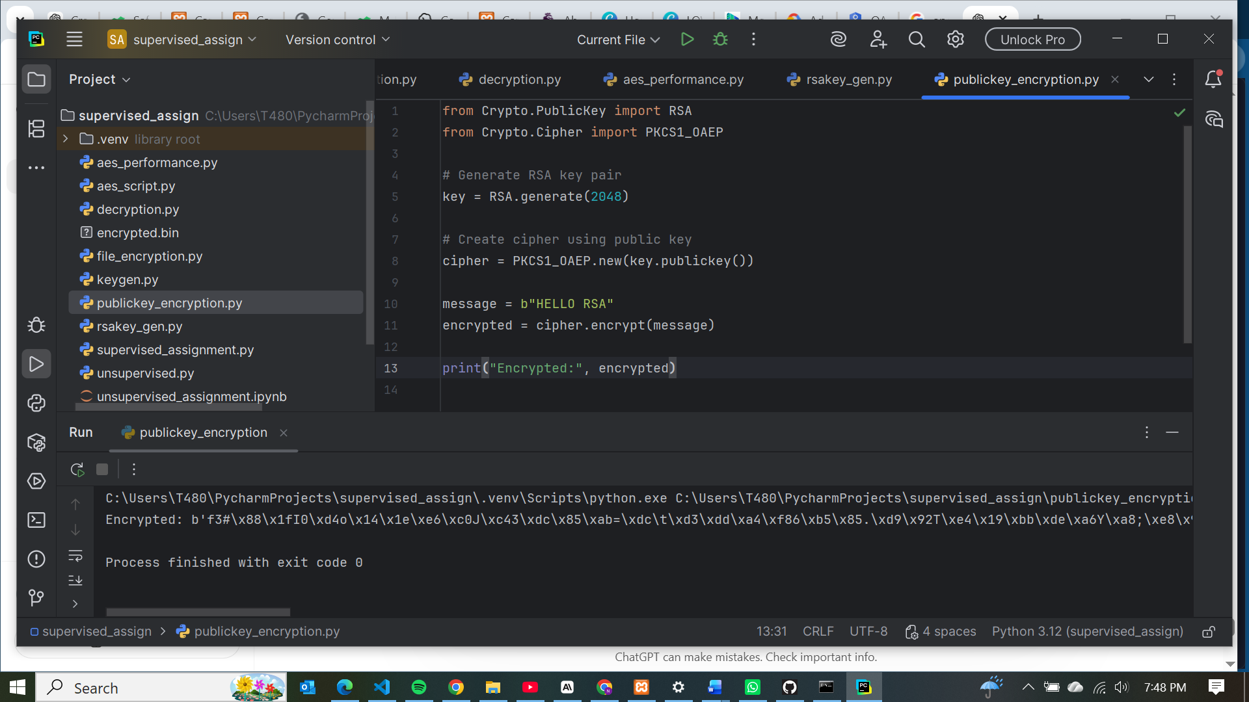

Fig 3: Private Key Decryption Results
The message encrypted above is now decrypted by a private key back to a plaintext.
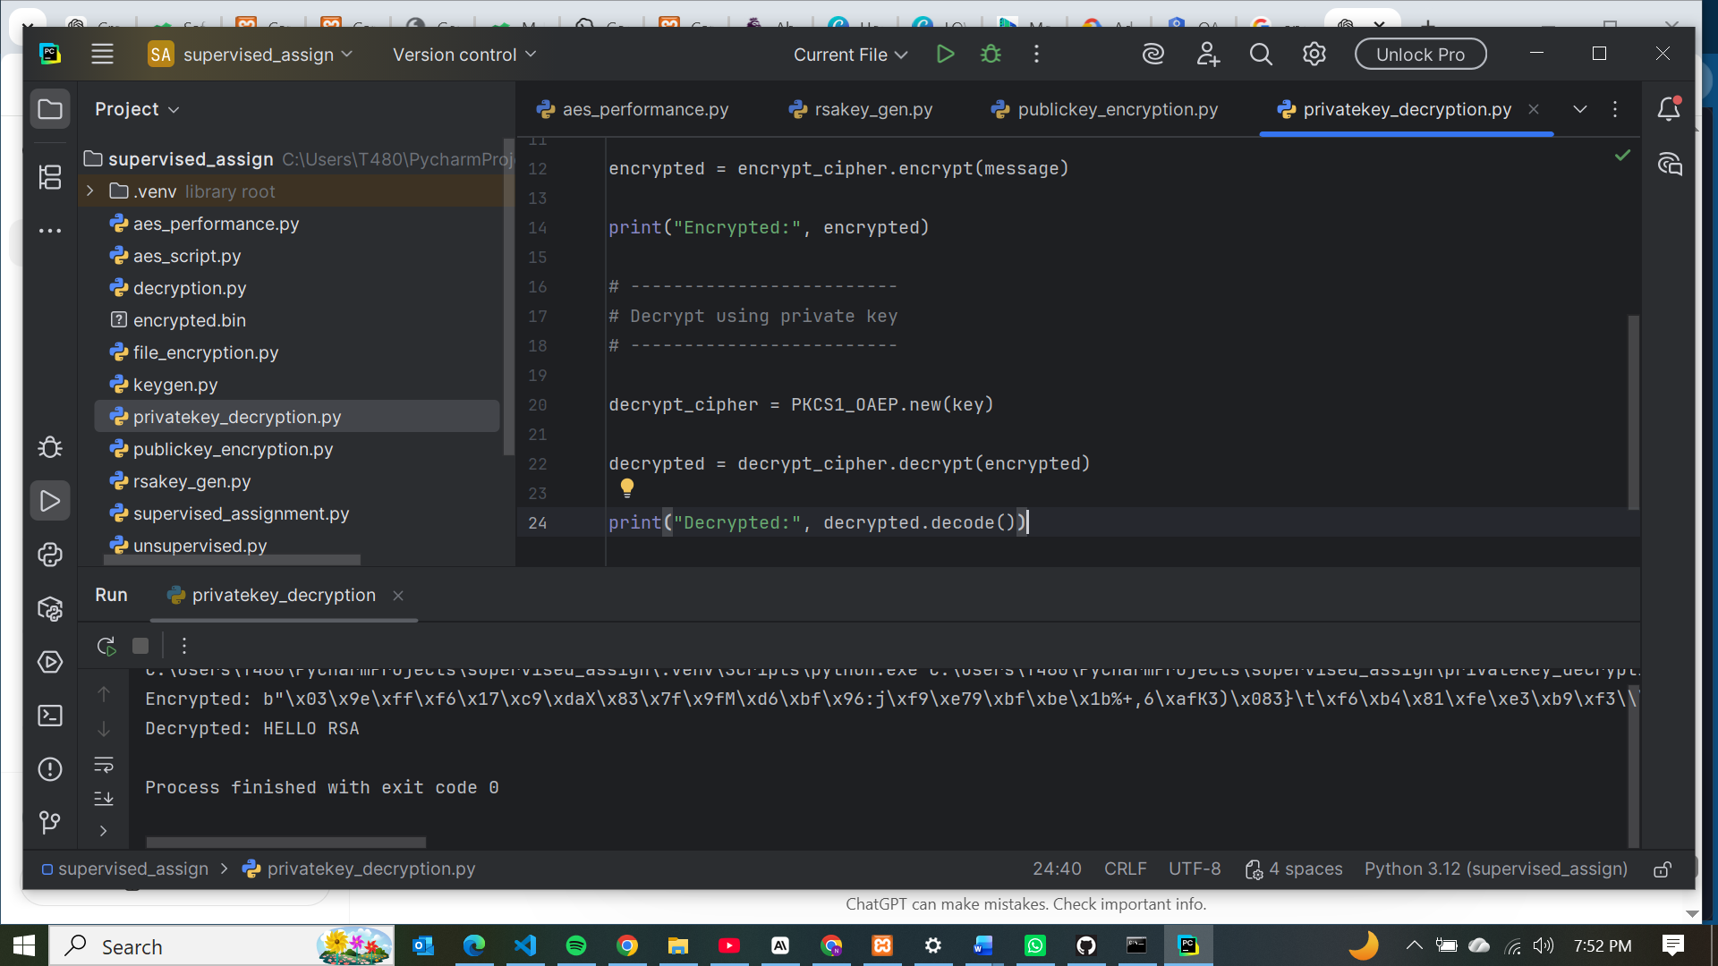

Fig 4: Secure Message Transmission
For this task the message transmission from plaintext to ciphertext and back to plaintext is clearly shown by the screenshots provided in figure 2 and 3 where we generate a public and private key, encrypt the message and later decrypt.

Fig 5: RSA Testing and Validation
This figure shows that RSA is efficient in encrypting a message that it reaches to the intended user( having recovered all messages).
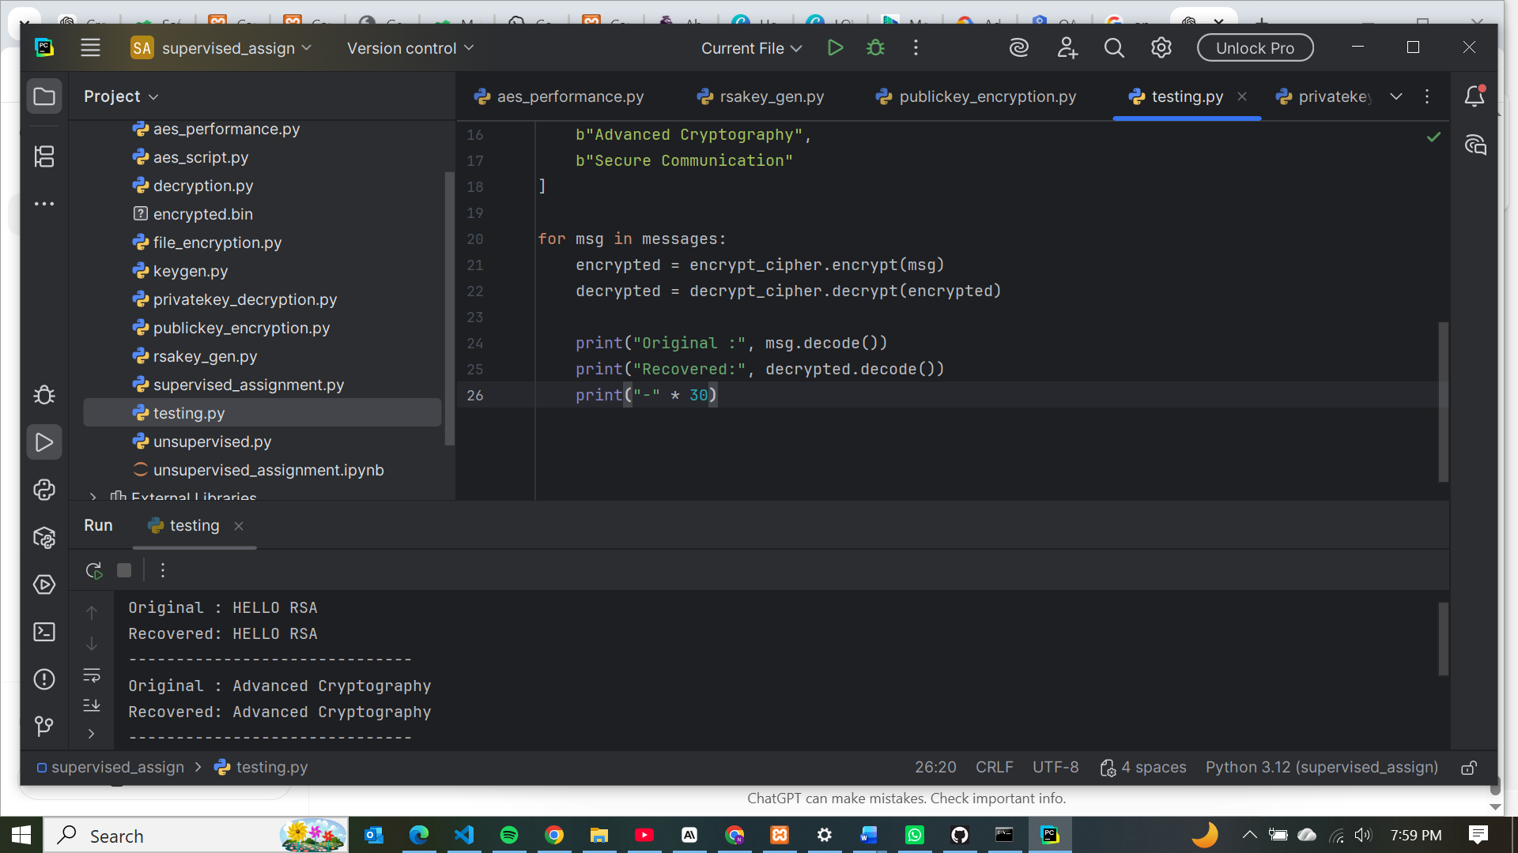

Student Reflection
RSA illustrates the difference between symmetric and asymmetric encryption, where public keys encrypt and private keys decrypt. This separation enhances security by avoiding shared secrets. Testing confirmed secure message transmission, validating RSA’s advantage in confidentiality and key management compared to symmetric methods.

